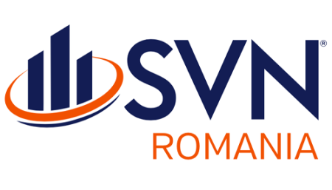
12 Paris Street, Room 1, Bucharest,
Phone: 0317 100 200 , email:. office@svn.ro

REQUEST FORM FOR ACCESS TO YOUR PERSONAL DATA

You have the right to request the personal data we may hold about you.
The data subject is a person who is the subject of the processing of personal data.
If you would like to make a request, please complete this form and forward it to the following email address:
dpo@svn.ro
Please write " TARGET PERSON REQUEST " in the subject field of the email.
1. Full name of the data subject | 2. Date of birth
3. Current address of the data subject
4. Telephone number of the data subject
Landline: | Mobile Phone:
5. Details of the requested data:
6. To help us search for the information you are requesting, please provide us with as much detail as possible about the data you are requesting (e.g. copies of emails between <date> and <date>).
If we do not receive sufficient information to find the data you request, we may not be able to fully comply with your request.
7. Will the information be transmitted to the data subject or their representative?
To the data subject ☐ To the representative ☐
8. I confirm that I am the data subject
Signature: __________________________

Full name: ____________________________________________________

Date: __________.

I am attaching a photocopy of my identity document to the email .

9. (To be completed if question 7 is answered with "to the representative")
The data subject (whose data is requested) must give written authorization/authorization for the information to be communicated to their authorized representative.
I hereby authorize: ________________________________________________ (fill in the name of the person empowered/authorized to represent you) to request access to my personal data.

Signature of the person concerned: ____________________

Full name : _________________________________________________________

10. (To be completed by the representative of the data subject) I confirm that I am the authorized representative of the data subject.
Name of authorized representative and address to which personal data should be sent:
_________________________________________________________________________________________________________________________________________________

Signature:____________

Full name____________________________________________________

Date: __________

We will make every effort to process the data subject access request as soon as possible, within 30 calendar days. However, if you have any questions while your request is being processed, please do not hesitate to contact the DPO – tel. 0745106965.

